About Booz Allen 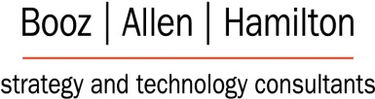
Booz Allen Hamilton Inc. (Booz Allen) is a consulting firm headquartered in Tysons Corner, Fairfax County, Virginia, with 80 other offices throughout the United States. It is recognized as one of the most prestigious technology consulting firms in the world and one of the best consulting firms to work for by Consulting Magazine. Founded in 1914 by Edwin G. Booz, the company is one of the oldest management consulting firms in the world.
Booz Allen Hamilton is engaged in providing management and technology consulting services to the United States government and commercial services. Booz Allen’s services include strategic planning, human capital and learning, communications, operational improvement, information technology work, systems engineering, organizational change efforts, modeling and simulation, program management, assurance and resilience, and economic business analysis.
As the needs of our clients have grown more complex, Booz Allen has expanded beyond its management consulting foundation to develop deep expertise in technology, engineering, and analytics. Today and into the future, powerful ideas embrace both strategy and technology. Booz Allen Hamilton’s technical, engineering and analytic excellence is backed by strategy, which enables our clients to rest assured that their solution will meet the full mission and business.
ABSTRACT
Collaboration and communication are seemingly thought to happen via some natural occurrence once engineering and technology are put into place. There is a false sense of “knowledge transfer” when explicit data is placed onto computer systems for sharing. The technology deals fundamentally with data stores, formats, networks, decision tools, mining and analysis, and standards. While these logical and physical factors have great value, they must be balanced by tacit knowledge. This tacit knowledge comes from people and their experiences. Some factors to consider with people are capacity to share, attitudes, motivation, objectives, community, culture, innovation, invention, value to self, value of self and language.
The other component to consider is the “process and method” - meaning the steps to doing some unit of work and “HOW” that work is performed. It is finding the right balance of explicit information and tacit or “know how.” To accomplish the process and method aspects of this work, there is a requirement for maps, workflow, best practice, standards and project framing. Additionally, teams require facilitation and interaction among team members with established trust relationships.

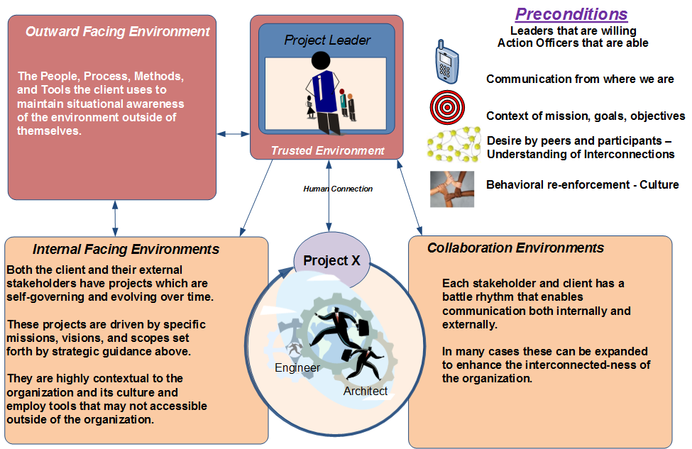  The Collaboration Pattern  Organizations require processes, methods, and tools to transfer and share and retain knowledge smartly. Most leaders today focus on the data contributions of their organizations and not on the people with the knowledge. However, data without context requires an interpretation and trust when consumed. In the absence of an organization’s trust in data and their own ability to accurately interpret the data, the value of the data is diminished and the knowledge lost. The problem is further compounded by the mobility of data without context. Organizations will frequently mitigate this problem by focusing on the logical transfer of explicit knowledge. This approach solves the wrong problem precisely.  We know that the value of data transferred mechanically through technology is diminished through interpretations. Organizations require a process and methodology to accurately retain context through analysis, integration, and comprehension by its people. The collaboration pattern fills this gap by providing an assessment after observing and documenting the source of context and organizational trust. This service offering examines and documents the culture of the people, their processes methodologies, and requirements as derived from governance and the mission and business orientation.  Factors for Consideration:  Each is heavily rooted in the understanding of Human Conditions contextually related to project or task at hand. This approach uses a template or pattern as the foundation for discussion, sharing and common understanding of a project snapshot.  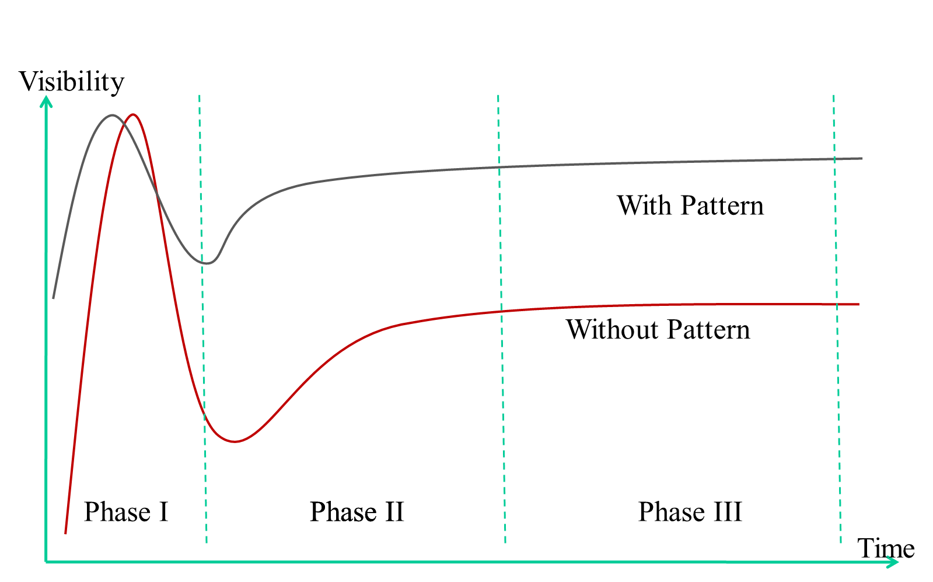  Hype Cycle in Action  Phase I (1 month) – Initial hype that most projects experience. Tremendous support/visibility, projects starts off with tremendous interest.  Initial understanding of the Impact to the client is accomplished, perhaps using various problem and solution models for analysis. Example model is (SARA) Scan, Analyze, Respond, Assess.  Phase II (3-6 months) – This is where the pattern is most beneficial. Shortening the time that projects usually stall. Groundwork is completed to stand up and train the organization on the process and methods. Continue to support project and identify the benefits and practical application of the technology  Phase III (6-12 months) – The process and methods are in place and become mature and accepted business culture of your organization. Transfer from team to organization is completed.  Tied to Gartner Hype Cycle Knowledge Nugget | Notes:
  Collaboration Pattern – Squeeze the hype cycle (Gartner) by helping clients scope realistic expectations | Examination of process, practice and methods (Explicit and Tacit Knowledge)
  Examination of process, practice and methods (Explicit and Tacit Knowledge) | Analysis of core problem sets as opposed to symptoms
  Sharing of best practices and lessons learned through a discovery process. (What can we learn from ourselves?) | Metrics (Usage of data to identify and understand trends)
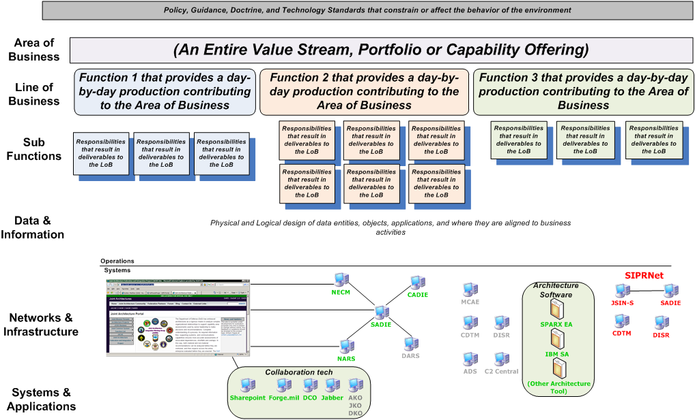  FEA Model  The Federal Enterprise Architecture (FEA) model is a useful means of track integration points with business areas of an enterprise. In many cases, these business areas are “complex.” Labeling a business area as simple or complex is important to a knowledge manager because complex business areas are always self-governing, evolving, and interacts with other business areas in non-linear ways. Internally, these areas require repeatable best practices that impact the delivery of services, functional interoperability, resource optimization, and authoritative references. The effects of a repeatable architecture project method on knowledge management are increases in return on investment in strategic planning, capital planning, program management, human capital management, and cyber security.  The transfer of knowledge, both tacit and implicit, occurs through the communication of employees. Technology can enable the exchange of information and data, but there will always be a human in the loop to consume, interpret, and rearticulate knowledge. Enterprise models provide awareness of these non-linear communications and business development between people and organizations and how well their technology resources enable them to function. The knowledge manager will be able to recognize the alignment of information and data transfers in both vertical and horizontal perspectives. The horizontal perspectives being the most important in many cases and the knowledge manager frequently works with stove-piped organizations.  Factors for Consideration:  A template driven approach based on lessons learned and best practices for collaboration. | Notes:
  Enterprise Architectures in the form of As-Is, As-Desired, As-Implemented | Traceability from Policy, Standards and Guidance to Practice and Implementation
  Extensible Approach (Agile methods employed by use of a small team in an iterative lifecycle) | Complex systems and process requires easy to understand modeling and traceability
  Who governs your process and practice? | How do you have the right and ability to execute?
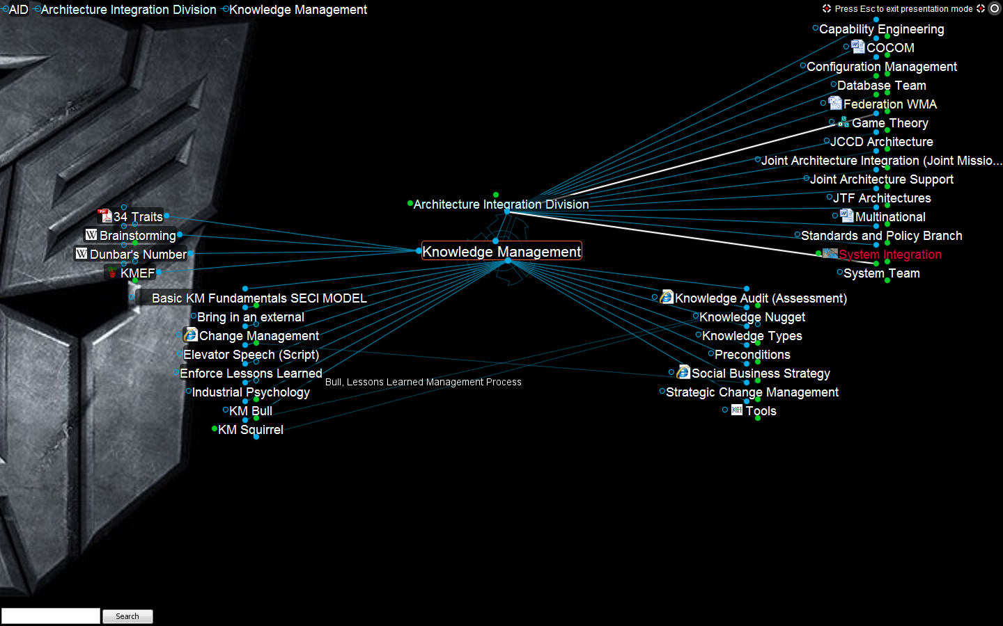  Personal Brain  The Brain is a personal knowledge management tool that enables users to take traditional mind mapping to new level. This tool specifically allows for users to define objects and relationships quickly and tag those objects textually and visually. The focus on the “Plex” which is the main interface that allows the user to focus on the relationships on the central node. The central node is the place where the user pays attention. The relationships branch off in parent, child and jump relationships that can have one to many or many to many connections. Additionally the user can create “link types” and differentiate linkages by visual and textual methods. Through the use of tagging, visual line thickness, color and pictures the view in the Plex allows users to have a better understanding of the meaning behind the relationships.  The Brain tool enables a multidimensional visual representation of objects and their relationships through a 2 dimensional interface. This interface allows for “stacking” which can increase the actual extensibility of the user experience into the 3rd dimension. This is important to understand because the relationships you see in the plex on a node or object may have other relationships behind them. When the human interacts with the interface and changes the view the nature of these hidden relationships is revealed.  Factors for Consideration:  Tied to Personal KM Knowledge nugget as described by KMI. | Notes
  Potential for Explicit Knowledge Sharing | Visual User Interface for KM
  Potential for Tacit Knowledge Sharing | Extensive Capability for Human to Machine Data Sharing (Use of XML)
  Potential for Personal KM Analysis | Potential for Consumption of Multiple Data Types

