

Digital Capabilities Collaboration Services
  - Playbook

Our Mission
To discover, develop and deliver innovative medicines that help patients prevail over serious diseases.

Our Commitment
To our patients and customers, employees, global communities, shareholders, environment and other stakeholders, we promise to act on our belief that the priceless ingredient of every product is the integrity of its maker. We operate with effective governance and high standards of ethical behavior. We seek transparency and dialogue with our stakeholders to improve our understanding of their needs. We take our commitment to economic, social and environmental sustainability seriously, and extend this expectation to our partners and suppliers.

To our patients and customers
We commit to scientific excellence and investment in biopharmaceutical research and development to provide innovative, high-quality medicines that address the unmet medical needs of patients with serious diseases. We apply scientific rigor to produce clinical and economic benefit through medicines that improve patients’ lives. We strive to make information about our commercialized medicines widely and readily available.

To our employees
We embrace a diverse workforce and inclusive culture. The health, safety, professional development, work-life balance and equitable, respectful treatment of our employees are among our highest priorities.

To our shareholders
We strive to produce sustained strong performance and shareholder value.

To our environment
We encourage the preservation of natural resources and strive to minimize the environmental impact of our operations and products.


“We are a global biopharmaceutical company whose mission is to discover, develop and deliver innovative medicines that help patients prevail over serious diseases.”
Drivers for Collaboration

BMS is a global biopharmaceutical company that carries out the discovery, development, licensing, manufacture, marketing, distribution and sale of pharmaceutical and other healthcare-related products. With its strong portfolio of oncology products and strong research and development activities, the company is in a secure position and at a leading position in the pharmaceutical and healthcare market.
Each day, our employees around the world work together for patients – it drives everything we do. We are focused on helping millions of patients around the world in disease areas such as oncology, cardiovascular, immunoscience and fibrosis. Through our R&D organization, we have built a sustainable pipeline of potential therapies, and actively partner to access external innovation to broaden and accelerate our work.
As global citizens, we work sustainably, responsibly and seek to give back. Through the Bristol-Myers Squibb Foundation, we promote health equity and strive to improve health outcomes of populations disproportionately affected by serious diseases and conditions, giving new hope to some of the world’s most vulnerable people.
Source: BMS


About this Playbook

Purpose
This playbook for provides an approach to establish a future vision for the digital capabilities associated with collaboration services and assets used for knowledge sharing and productivity at Bristol Myers Squibb (BMS). End to end delivery of digital capabilities requires an understanding of business organizational needs, partnership, organizational objectives and alignment with the underlying mission; “to discover, develop and deliver innovative medicines that help patients prevail over serious diseases.” Shared services that are available, accessible and understandable as digital resources, create greater opportunities for revenue generation, increased operational efficiencies, and risk mitigation. This fundamentally helps the people of BMS and its partners accomplish their goals and objectives with greater ease, increased speed and efficiency.
This Playbook provides a high-level process for strategy, design, implementation and management of global collaboration services and applies notionally to the BMS eco-system.
It’s organized as follows:
- Part A provides an overview of the major stages and activities for the digital workplace and collaboration services.
- Part B describes each activity in more detail. * Part B/C to be created.
- Part C apply strategies and activities to the BMS eco-system. *

Audience
This Playbook is intended for IT teams, partners, leaders and practitioners. The collaboration services team uses it as a reference to:
- Get a better picture of what lies ahead
- Communicate a consistent story to management and end users
- Anticipate and prepare for the next step
- Ensure that nothing is left out

Related Information
This Playbook should be used in conjunction with the following documents:
- Collaboration Services Team
- Business Summary
- Stakeholder Engagement Plan
- Communication Strategy

Using this Playbook
In this playbook, Collaboration Services refers to the services which enable collaboration and connectivity of our global workforce and external partners, including email, instant messaging, web conferencing, video conferencing, audio conferencing, file sharing services (Intralinks, SharePoint, Box), OneDrive, streaming media solutions (BMSTV) and internal social media (Yammer, QuestionPro, Ideation).
These may be used by employees, consultants, in-house partners (for example, HR recruiters, on-site food service vendor, on-site facilities administrators), External partners (restricted access, for example, outsourced partners or managed service organization.) * Note: Digital Capability Management and Digital Workplace will be used for this document interchangeably.


Digital Capability Management, Collaboration Services Role

The Head, Digital Capability Management, Collaboration Services is accountable for the strategy, design, implementation and management of global collaboration services. Services are delivered through a core team of seven employees and an extended service provider workforce of approximately 50+ people. Responsibilities include financial management of a $30+ million operational, cloud service and software related budget and delivery of services which enable collaboration and connectivity of our global workforce and external partners. These services include email, instant messaging, web conferencing, video conferencing, audio conferencing, file sharing services (Intralinks, SharePoint, Box), OneDrive, streaming media solutions (BMSTV) and internal social media (Yammer, QuestionPro, Ideation). Additional responsibilities include, but are not limited to:
- Serve as platform owner for the Office 365 cloud based capabilities, partnering with architecture, technology engineering, change management and application teams to ensure alignment between the collaboration strategy and broader technology strategy.
- Develop, maintain, and execute a comprehensive collaboration strategy/roadmap, prioritizing technology investments and lifecycle management upgrades, and sponsoring/leading projects in the collaboration portfolio.
- Lead contract negotiations and provide operational/financial oversight of key service delivery, outsourced, cloud and software agreements. Work collaboratively with Procurement, Legal, Security and Privacy organizations to ensure contracts meet business, technical and financial goals.
- Partner with the business to understand significant organizational initiatives and changes; update roadmap and capabilities to meet business objectives.
- Serve on the Microsoft Office 365 Customer Advisory Board, advocating for Bristol-Myers Squibb to ensure the highest return on investment and influence the Microsoft roadmap.


Part A: Overview
A digital workplace and collaboration services design is comprised of eight stages:
- Define, review, and assess the digital capability management strategy
- Review or establish information and portfolio architecture
- Review or establish content strategy
- Review or establish collaboration strategy
- Review or establish change management strategy
- Review and update technology management and implementation
- Establish a governance framework
- Create a user adoption & employee engagement strategy
The strategy needs to be determined and/or reviewed first. Governance and Adoption start early and continue using Change Management practices. (see Figure 1).

Governance
Adoption & Employee Engagement
Collaboration Strategy
Change Management
Content
Strategy
Information Architecture
Digital Capability Management
Technology
Figure 1: Stages of a Digital Capabilities

Stage 1: Define, review, and assess the Digital Capability Management Strategy
This is the high-level plan to make the collaboration services useful, effective and impactful. It gives direction, guidance and purpose to everyone working with and for BMS on the utility and value of these resources and helps them make informed decisions. It seeks to answer some of the following questions:
- What are global collaboration services?
- Why are global collaboration services important?
- How can we leverage these services and maximize their value?
- What is the relative value? How will we measure impact on the people and organization holistically?
- How do collaboration services align with the greater technology strategy?
- What business problems and organizational initiatives are aligned with strategic partner objectives?
- What does the roadmap including prioritized investments, lifecycle management and portfolio look like?

Stage 2: Review Information and Portfolio Architecture
Information architecture (IA) is the art and science of organizing information. An IA helps staff classify and locate information easily. Information ranges from simple stand-alone pages to large knowledge bases.
Portfolio architecture (PA) is the art and science of organizing solutions or solution patterns. Information ranges from individual solutions or stand-alone software to system integration patterns and system of systems architectures.
The activities in this stage include:
- Identify and review technical and content inventory
- Design or review the technology portfolio
- Review collections
- Review metadata and controlled vocabularies

Stage 3: Review Content Strategy
Content strategy is a systematic approach to planning, creating, and managing content. There are two types of content:
- Common or global content
- Specific or local content
Common or global content is relevant to all staff. These include:
- Communications: Company level communications such as news, events, press releases, and other company-related information
- Shared Services: HR, finance, procurement, communications, security, legal, branding, compliance
- Business Area Interfaces: Policies, forms, processes, procedures, and required applications that interface with businesses areas
To be effective, content in common areas is written and presented in an end-user-friendly style. Such a style helps end-users find the right information and accomplish tasks with ease, to improve trust in the capabilities, and in turn lead to increased use.
The following activities define a common content strategy:
- Review publishing and collaboration practices concerning content
- Identify content owners
- Scope common content
- Create a content management decision matrix
Specific or local content is specific to teams or departments. For example, R&D efforts in the oncology (including immuno-oncology), immunoscience, cardiovascular, fibrotic disease and genetically defined diseases (GDD) areas that have content specifically relating to their work. This content is not required outside the team or department, unlike common content.
Decisions to move or manage specific content are difficult. Questions to ask include:
- What happens to specific or local content in the cloud?
- What moves to the new systems or stays in the current locations?
- How will content be moved and why should we move it?
- How do owners review the content before moving?
The following are activities for a specific or local content strategy:
- Review existing content
- Work with information assurance and security to provide tools
- Assist with identification of management tools and practice

Stage 4: Review Collaboration Strategy and Pattern
Collaboration is one of the prime drivers for initiating a digital workplace strategy. Collaboration cuts through barriers and allows staff to work across organizational boundaries to enable knowledge sharing, improve productivity, and ultimately positively impact the bottom line; however, global collaboration presents a significant challenge. End users may not be familiar with working in an online social environment. They know the nuances and exchanges to collaborate in a face-to-face environment, but online collaboration presents fears, uncertainties, and doubts to overcome. A clear collaboration strategy helps bridge these gaps.
The following are the activities in this stage:
- Determine a collaboration model or pattern
- Establish collaboration roles and responsibilities
- Focus on adoption
- Establish collaboration governance with leadership and business stakeholder buy-in

Stage 5: Review Change Management
Change Management strategy addresses the reasons behind organizational change and realizing the value of change practices. Organizations don’t change, the people change. Change happens through structured practice. Employees resist change due to lack of awareness, concerns about job or role and observations of organizational past performance with change. BMS has a long history of change and growth. This is part of the corporate history and culture and is an important part of collaboration services and capabilities.
The following are activities in this stage include:
- Identify change activities or levers currently in use by BMS
- Work with business partners, IT and HR on communications
- Leverage best industry practices where advisable and appropriate

Stage 6: Implement Technology
Although implementing technology is an important stage, the success of the implementation depends on the success of the earlier stages and on the capabilities of the team (internal or external).
The activities to implement the technology stage include:
- Gather technology requirements (understand the problem we are solving)
- Work with our vendor partners, enterprise architecture, security and finance teams
- Create a roadmap and portfolio of services and functional capabilities
The success of the implementation is based on how faithfully it represents the digital workplace strategy.

Stage 7: Determine a Governance Framework
A governance framework is a standard approach that puts controls of policy, standards or guidance on all areas of a digital eco-system. Governance is key to the success of BMS and must be planned as part of the overall strategy.
Many governance activities involve a change management as a predecessor. It is important that senior management and business leaders are involved and support the cultural change at all levels.

Stage 8: Create a User Adoption and Employee Engagement Strategy
The adoption / engagement strategy stage is extremely important to the success of any services implementation. The primary objective is to serve the BMS community and provide the services and understanding of these capabilities to the people we serve.
Delivery of service is less about technical delivery and more about managing the impending change. People need to be informed, trained, and supported to make the most of the new capabilities as they are presented.
The following activities help users make the change successfully:
- Identify champions
- Hold briefing sessions on new features and functions
- Prepare support materials
- Open support channels
- Keep the enthusiasm going
- Define measures of performance and effectiveness
- Partner with Human Resources

Part B: Detailed Activities for Each Stage
This playbook is an example product. Notional concepts and ideas to inspire and engage people in the context of collaboration.

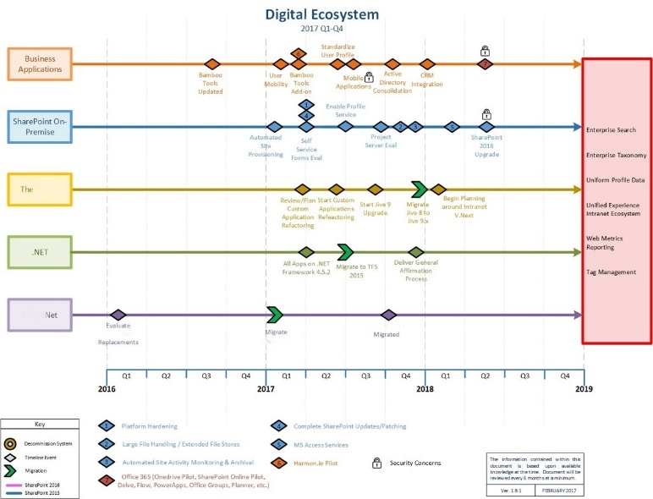
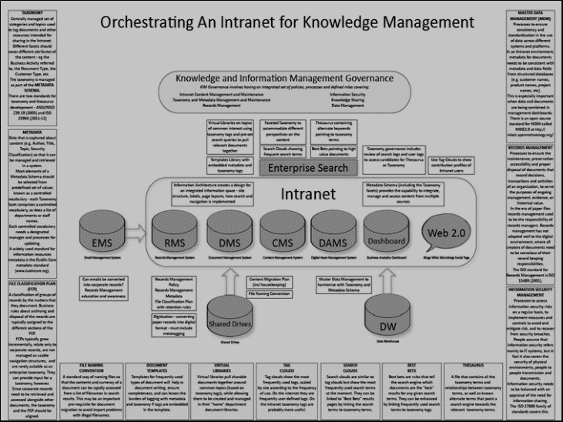
Work closely across Information Technology, Business Leaders and Partners to create relationships between the technical work associated with collaboration and the mission, vision, and commitment to our patients and customers, employees, shareholders and environment.

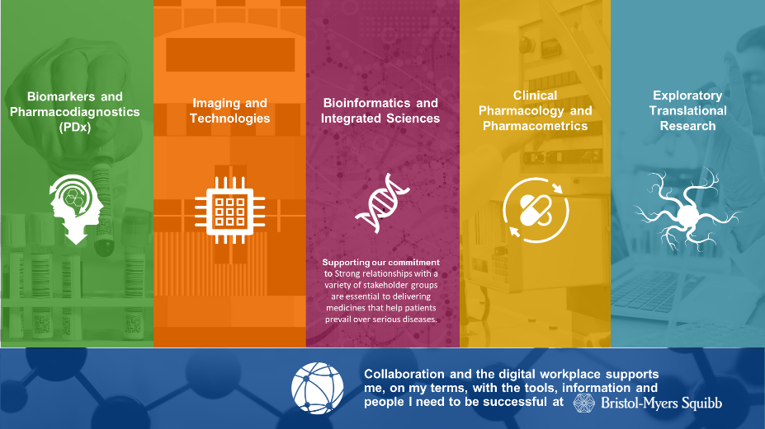

Vision

Howie Cohen https://www.linkedin.com/in/hcohen/
Howardscohenmba@gmail.com
“I met Howie Cohen in a meeting back in October 2015. His persona and ability to communicate is intriguing. He shares his thoughts and vision in such a way that was refreshing from anything that I have ever experienced. His presentation style is open and inviting, engaging and thorough - he knows how to wake up a room and have everyone listen - wanting more. He strives for more and when you work with him - you can’t help but attempt to exceed expectations in the same regards to be close to his level. It is rare to find a leader that radiates the integrity and respect that Howard Cohen has.” – Lea Reznik
“Howie's mission is simple; "Make the world a better place". All of his actions, behaviors and decisions just reinforce his commitment to that mission. He's an inspirational leader, outstanding mentor and one of the most transparent, collaborative and engaging managers that I've had the pleasure of working for.” – John Benfield
“I’ve had the privilege of working for Howie for the past few years and cannot express how lucky and humbled I feel to have had this experience. The outstanding passion, dedication and support that Howie bestows upon our team has far surpassed all managers/leaders I’ve worked with in my 30 plus years in IT.” – Deb Skolnick
“Howie is a thoughtful and intelligent person with great integrity, honor, loyalty and energy. He is passionate about his work. Being a visionary with positive outlook, he’s an inspiring and supportive leader, great at sharing valuable knowledge, bringing people together, and challenging teams to come with creative viable solutions for what’s best for the company and customers.” – Richard Morris
“Howie is the best manager I have known. He is supportive of his staff and colleagues, intelligent and passionate about his field of expertise, and works hard and creatively to get results. He brings out the best in his staff by being available, informed, and honest. He is intelligent and well-versed in many areas but has no problem researching other topics and alternative solutions if necessary. He is willing to work with all levels of management to get results that are in the best interest of the company but balances his efforts with honesty, compassion, and fairness for all that work for and with him on initiatives.” – Pat Cornetto
“Few people have the opportunity to report to a manager who is also a coach and mentor—but I did when I worked for Howie. I had the pleasure of working with Howie for two years at Chubb, collaborating on multiple projects and delivering thought changing insight. I was particularly impressed by Howie's ability to handle tough situations with projects and with the people who reported to him - effortlessly. Howie's ability to command a room and get people on board with ideas - even people who were initially on completely different pages was masterful.” – Nick Thomas
“Howard (Howie) Cohen had a significant impact on me and I will be forever grateful for his influence and leadership. He saw my potential and gave me the freedom to exercise it. In addition, Howie was approachable and personable, available to discuss or provide advice at a moment’s notice.” – Andrew Craig
“I have had many managers in my 40 or so years of working. Only a few, very few stand out. Howie is a standout, standup guy. He became my manager and also my mentor (although he is substantially younger than I am) because he knows so much and is so willing to share his knowledge and experience.” – Tina Durham
Howie Cohen

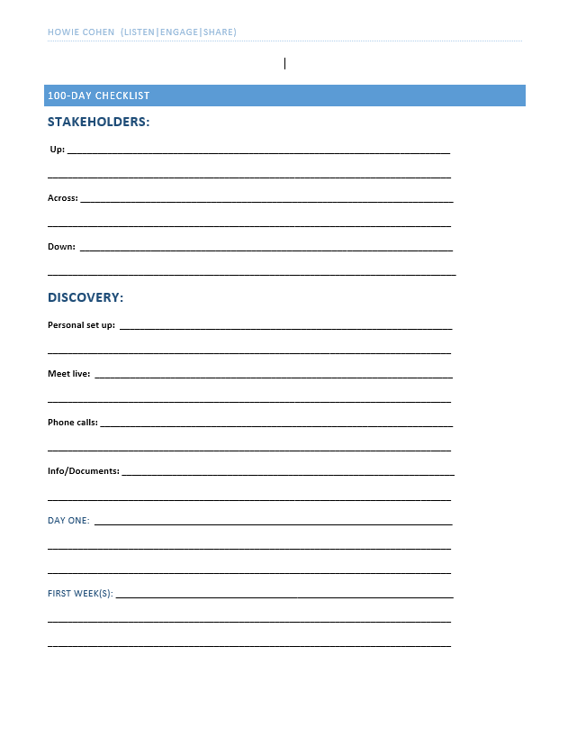
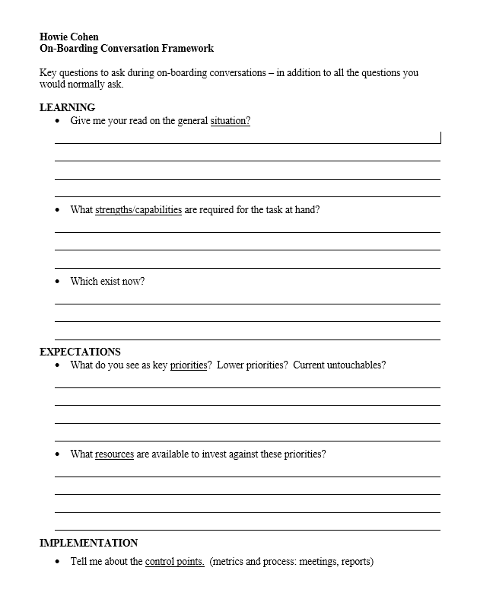
100 Day Plan
Learn more about BMS
History, Financials, Charter, Mandates

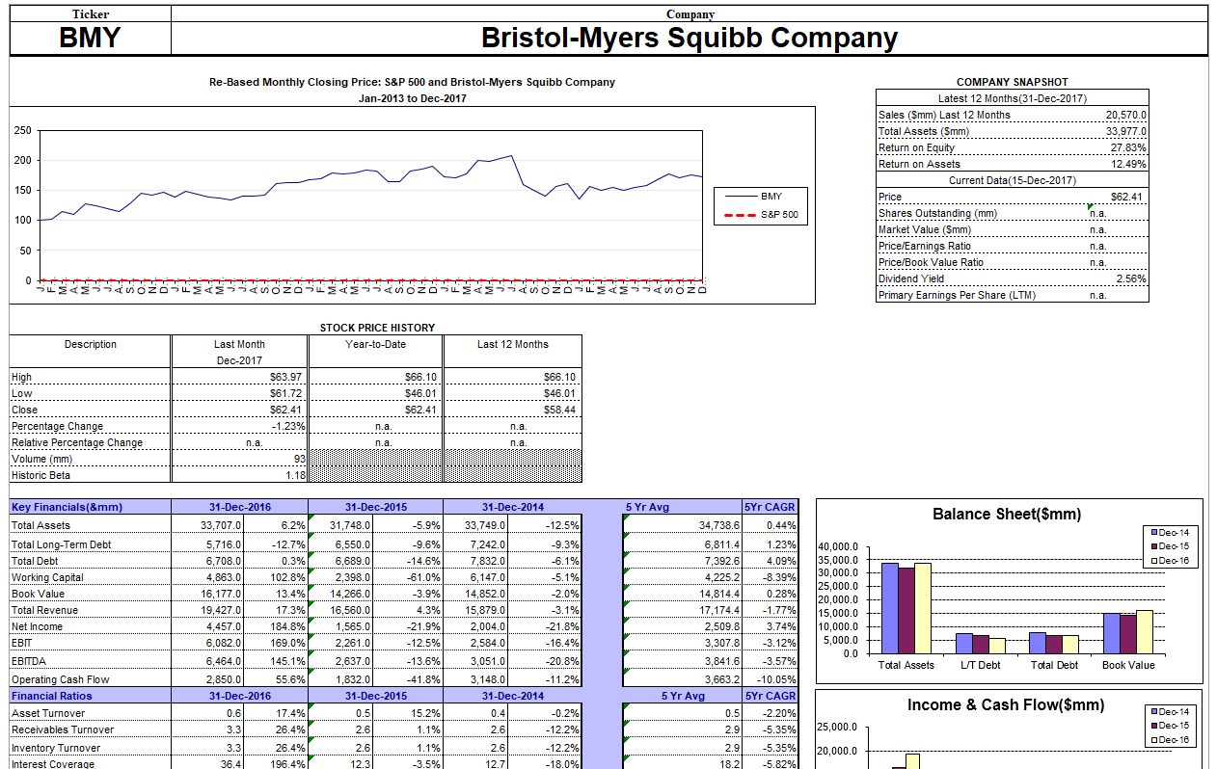
First 100 days, I will meet with Employees, Partners, Leaders to introduce myself and learn from them about who they are, what they do, including their goals and objectives and desired outcomes.

